ELEC 4700

Assignment 1

Monte Carlo Modelling of Electron Transport

Chad Blanchette 100968854

Part 1:

The thermal velocity was shown to be 1.61E5 from the Matlab script titled part 1.The following figure is the 2D electron transport modelling

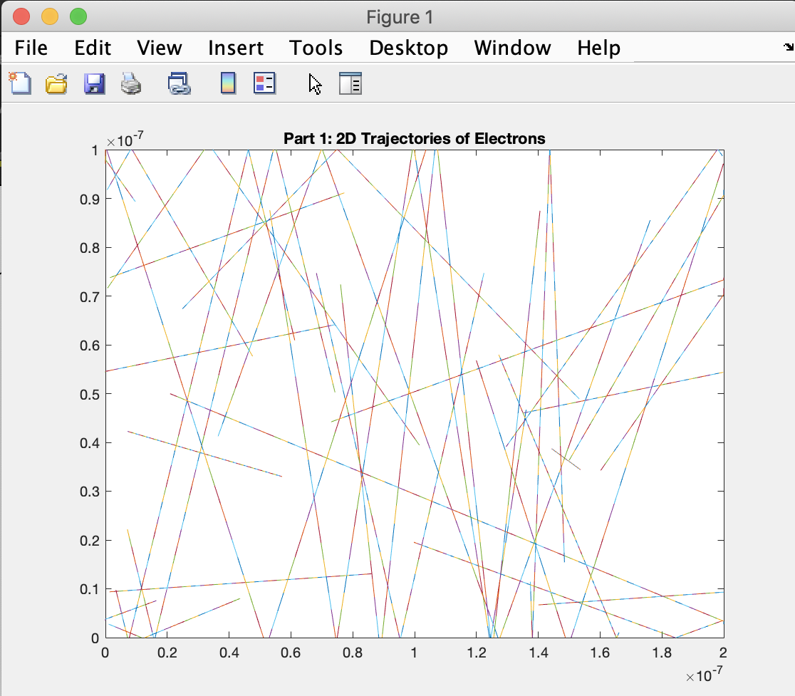

Figure 1: 2D Trajectories of Electrons

When I tried to implement the temperature plot it stayed at 300K constantly, I am unsure how to update it with each time step. I will need to ask questions and get help from the TA in the next PA session this week.

Part 2:

I ran into the same issue with the temperature in this section since part 2 is dependent on part 1, therefore I did not include the temperature plot because I need assistance from a TA. The following is a graph of the histogram of velocities over time.

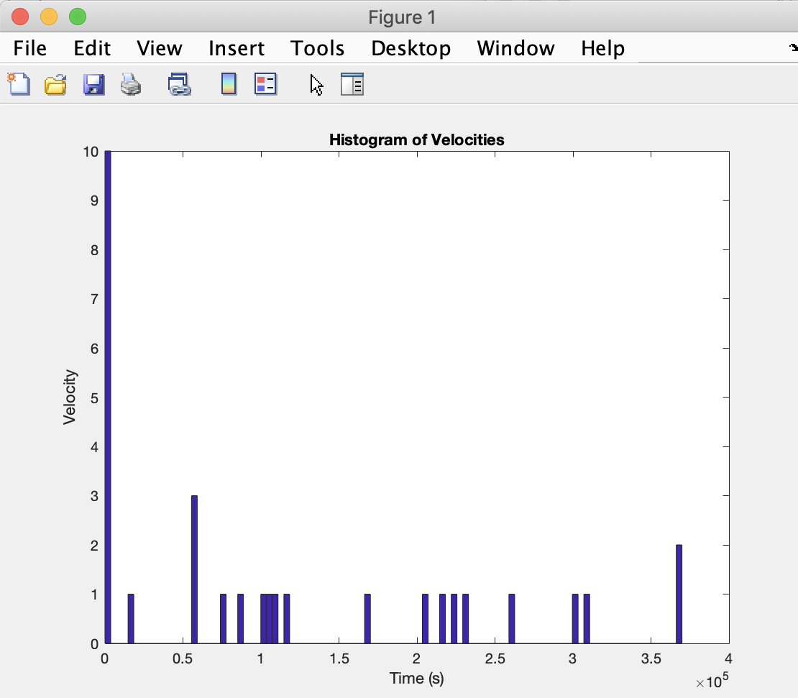

Figure 2: Histogram of the Velocities

The following figure illustrates how the implementation of scattering can affect the electron pathways. When the electron scatters the velocities become updated with new x and y components and start travelling in a new direction.

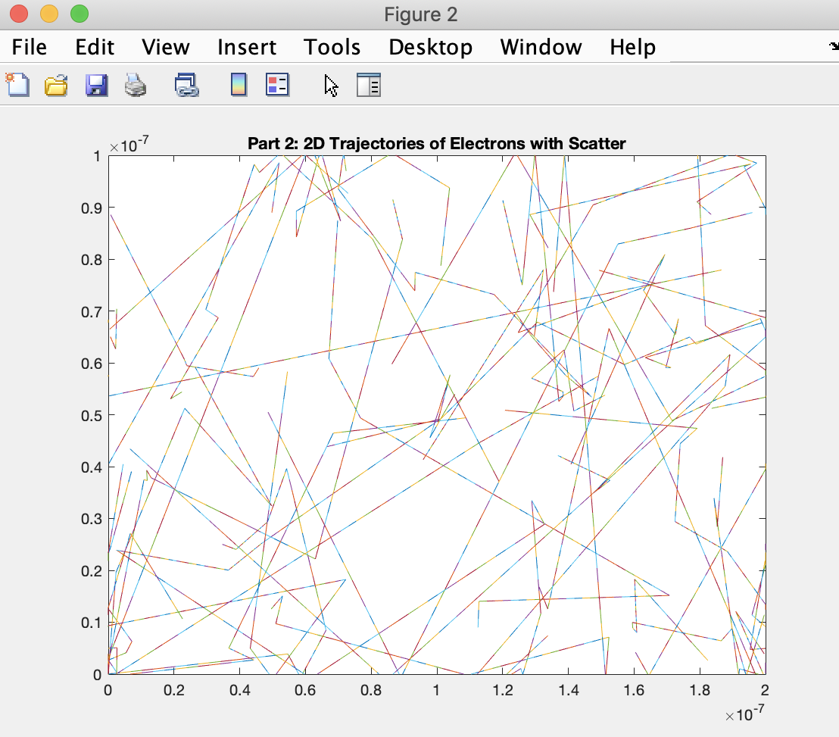

Figure 3: 2D Trajectories of Electrons with Scatter

Part 3:

Unfortunately, the box implementation did not work from my attempts. As said in the assignment guideline document on the course website I will ask the TA for further assistance and continue to try to fix this issue to recover the grade that I lost in this section. I will be emailing the TA’s this week to arrange a time where I can get help so I can continue the progression of the PA’s and assignments and feel more comfortable with Matlab since I haven’t used it in a while.